

**PARENT INFORMATION LEAFLET**

**Development and Evaluation of an online FeNO-guided asthma management INtervEntion in primary care: feasibility study (DEFINE-Feasibility)**

We'd like to invite your child to take part in our research study. Before you decide, it is important that you understand why the research is being done and what it would involve for your child. Please take time to read this information, and discuss it with others if you wish. *If there is anything that is not clear, or if* you *would like more information, please ask us.*

# What is the purpose of the study?

Asthma is a common condition which affects the airways of the lungs. In people with asthma, swelling (also known as inflammation) can occur in the linings of the airways and make them narrower than usual. This can cause symptoms such as wheezing, coughing, chest tightness and shortness of breath. If these symptoms flare up badly, people may get asthma attacks, which might need treatment with medicines to reduce inflammation (such as steroids) or admission to hospital.

At the moment, most health care professionals rely on patients’ symptoms to help them decide how to treat their asthma. However, how someone feels does not always match how much inflammation is in their airways or how likely they are to have an asthma attack. We are therefore developing an online package to support health care professionals in general practices with using a simple breath test called fractional exhaled nitric oxide (FeNO), which measures inflammation in the airways.

At the moment, FeNO is mainly measured in patients with severe asthma who attend hospital clinics. However, very few GP surgeries routinely use FeNO to help them monitor treatment in patients with milder forms of asthma. We would therefore like to find out why this is and learn more about feasibility and practicalities of using FeNO in general practice.

To achieve these aims, we are training health care professionals in GP surgeries in how to measure and use FeNO to help them make decisions about managing their patients’ asthma. We will ask general practices to implement FeNO in their asthma review consultations. Patients who agree to take part will have their FeNO measured during their asthma review. We would like to compare the decisions that were made during an asthma review in which FeNO was measured to recommended care. Also, we will ask patients and health care professionals about their views on using FeNO.

# Why have I been invited?

# Your child’s general practice surgery is taking part in this study. Your child has been invited because their general practice team has identified your child as someone who has asthma, who is due to have an asthma review.

# Do I have to take part?

No, taking part is entirely voluntary and your child can withdraw at any time if you later change your mind, without giving a reason. Withdrawal or not taking part will not affect your child’s current or future clinical care in any way, as the research team is separate from your health care team.

# What will happen to me if I decide to take part?

A researcher from the University of Oxford will talk to you and your child about the study and ask if you have any questions about taking part. If your child would like to take part, the researcher will ask you to complete a consent form and will ask your child to give assent.

During your asthma review appointment, your health care professional will measure your child’s FeNO. This will involve them breathing in through a disposable mouthpiece, connected to a machine, then breathing out gently for about 10 seconds. A display screen on the machine will help ensure that your child is breathing out at the right speed.

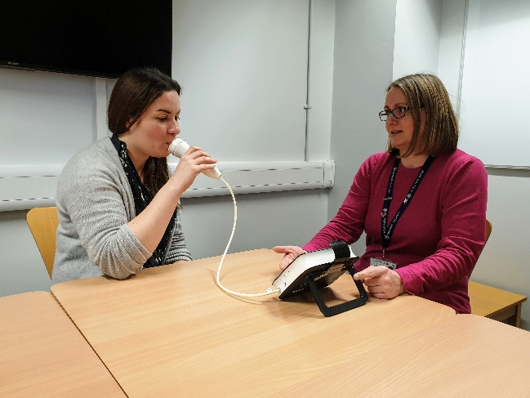

The FeNO mouthpiece is changed between each patient, and the machine is cleaned thoroughly.

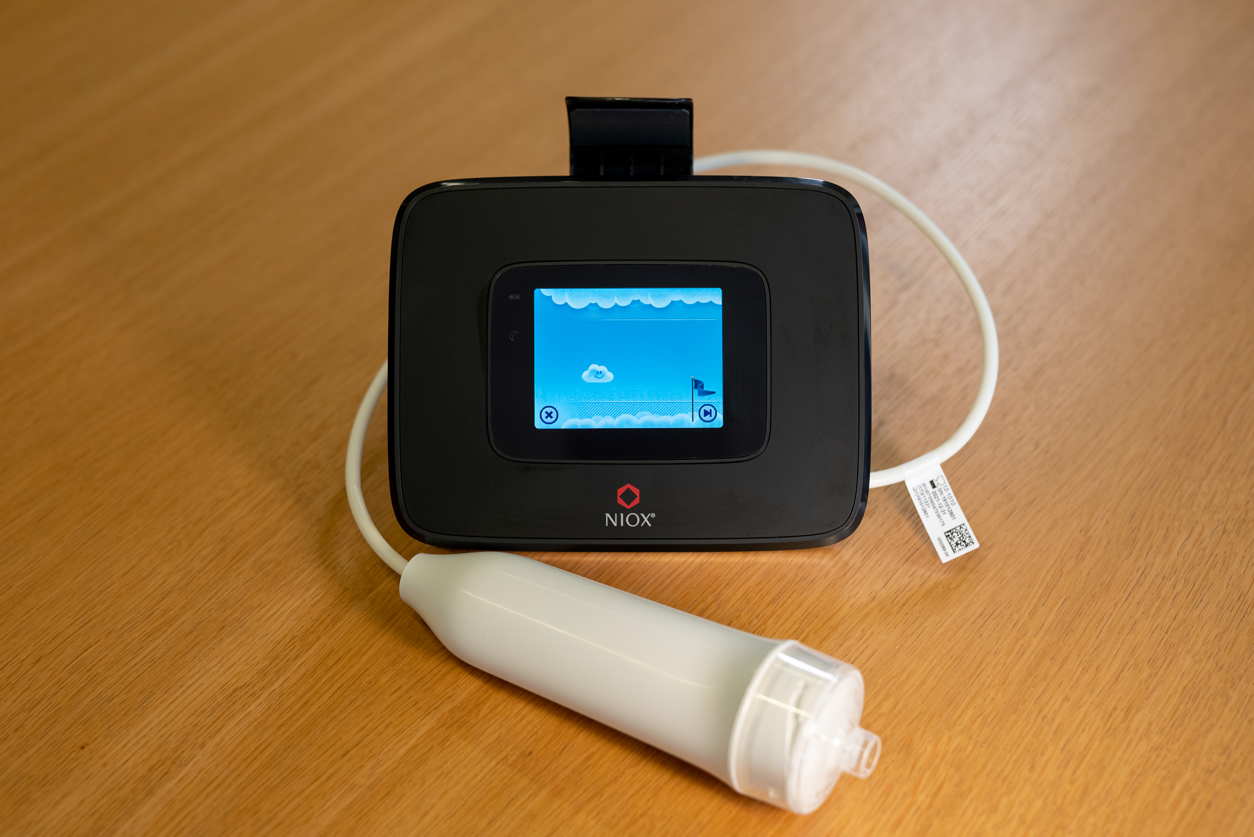

The FeNO machine – your child will be asked to hold the white breathing handle and blow into the clear mouthpiece on the end.

Your healthcare professional will follow the Covid-safe procedures of your GP Practice.

After their asthma appointment, the research team would like to look at your child’s medical records to see what decisions were made about your child’s care. We will ask look at your child’s FeNO result.

Additionally, we would like to ask you or your child to complete some questionnaires to ask about your child’s asthma, your child’s medicines, and your child’s views of the asthma review appointment. If your child might struggle to answer all of the questions, you can fill in the questionnaires for them.

The research team would also like to invite some participants and/or their parents to take part in an interview about the child’s asthma and experience of having their FeNO measured. The interview can be done remotely, for example by telephone, Microsoft Teams or Skype and would last no longer than one hour. We can provide participants invited to interviews with a separate information leaflet with further details .

# What should I consider?

The main things to consider are whether you and your child are comfortable with having your child’s FeNO measured and the possibility that your health care professional may wish to consider changing the way your child’s asthma is managed as a result of knowing the FeNO result.

# Are there any possible disadvantages or risks from taking part?

If your child has not done a FeNO test before, they might feel a bit anxious about what it involves. You can ask your GP Practice any questions. FeNO testing is already done in hospital clinics and is safe, painless, and easy to do.

If your child normally has their asthma review done over the telephone, they will have to go to the GP Practice to have their FeNO test done first. This may be less convenient than just having a telephone review. However, doing the test may give the healthcare professional more information about your child’s asthma so they can give better advice during the telephone review.

You or your child may have concerns about Covid-19 infection as a result of having to go to your GP Practice for the FeNO test. However, your GP Practice will put all necessary measures in place to keep you safe from Covid-19. This will include making sure the FeNO testing equipment is properly cleaned, and attaching a brand new mouthpiece to the machine before your child does the test.

You may have concerns about researchers seeing your child’s medical records. We would like to assure you that all data will be kept secure and confidential.

# What are the possible benefits of taking part?

The main benefit of taking part in the research is an opportunity for your child to contribute to a programme of research that focuses on improving how health care professionals in GP surgeries manage patients with asthma.

Your health care professional may also be able to make better informed decisions about how to manage your child’s asthma as a result of knowing your child’s FeNO result. For example, if your FeNO indicates a high level of inflammation in your child’s airways, they may increase the dose of your child’s existing medication or start your child on different medication to reduce this inflammation and lower their risk of having an asthma attack. On the other hand, if your child’s FeNO indicates a low level of inflammation and their asthma is well controlled, they may consider reducing the amount of medication your child needs to take.

# Will my taking part in the study be kept confidential?

Yes. All data from the study which we decide to share with anyone outside the research group or your child’s health care team will be de-identified unless you give us permission not to do this. They will be kept on a secure part of the server at the University of Oxford and accessible by the research team for three years after your child turns 18, after which point all audio recordings will be destroyed. In those stored data, your child will be referred to only by a code name (‘pseudonym’). We will keep a separate paper record in a locked cabinet of participants’ real names and corresponding code names.

Audio recordings may be processed by a transcriber with a contractual agreement with the University. Transcribers are subject to the same requirements of confidentiality as researchers. They will have no other identifying information about your child, and will not retain the audio recordings.

Responsible members of the University of Oxford and the relevant NHS Trust(s) may be given access to data for monitoring and/or audit of the study to ensure that the research is complying with applicable regulations.

In the highly unlikely event that we notice anything about your child’s care which we feel poses a serious risk to your child’s health or safety, we would have a duty to report this to the appropriate manager(s) at your GP surgery and your health care professional’s regulatory body. We would discuss this with you before doing so.

# Will I be reimbursed for taking part?

We will not offer reimbursement for having your child’s FeNO measured during your routine asthma review consultation. However, we can offer you a small token of £20 if you and/or your child are willing to be interviewed by a researcher after your child’s consultation.

# What will happen to my data?

Data protection regulation requires that we state the legal basis for processing information about your child. In the case of research, this is ‘a task in the public interest.’ The University of Oxford is the data controller and is responsible for looking after your information and using it properly. Your child’s GP surgery and study team will use your child’s name, NHS number, home address, email address and/or phone number to contact you about the research study and to oversee the quality of the study.

We will be using information from interviews and observations and will use the minimum personally-identifiable information possible. We will store research data (de-identified unless we have explicit consent to retain identifiers) and any research documents with personal information (such as consent forms) securely at the University of Oxford for up to three years after your child turns 18, following University of Oxford policy.

Data protection regulation provides you with control over your child’s personal data and how it is used. When you agree to your child’s information being used in research, however, some of those rights may be limited in order for the research to be reliable and accurate. Further information about your rights with respect to your personal data is available at <http://www.admin.ox.ac.uk/councilsec/compliance/gdpr/individualrights/>

You can find out more about how we use your child’s information by contacting Kay Wang, Chief Investigator for the study ( kay.wang@phc.ox.ac.uk).

Your child can stop at any time. Participation is voluntary and even if you and your child originally said yes, you may change your mind at a later stage. If your child withdraws from the study, unless you state otherwise, any interview material that has been collected whilst your child has been in the study will be used for research as detailed in this leaflet. You are free to request that your child’s data are destroyed at any time during or after the study.

Withdrawal from the study will NOT affect the care your child receives from the NHS now or in the future.

# What will happen at the end of the study?

We will analyse the data and write some papers and reports, including a ‘lay summary’. We will provide you and your child with a summary of the findings if you would like us to.

Your child will not be identified from any report or publication placed in the public domain, as we will ensure individual cannot be identified from any quotes.

Some of the research being undertaken may also contribute to the fulfilment of an educational requirement such as a doctoral thesis.

# What if you find something unexpected?

If we see or hear anything during your child’s consultation which gives us cause for concern about your child’s clinical care, we would in the first instance advise you on the appropriate complaints processes to follow, or we would notify the appropriate managers in your child’s GP surgery. We would not be able to support you in a complaint.

# What if there is a problem?

The University of Oxford, as Sponsor, has appropriate insurance in place in the unlikely event that your child suffers any harm as a direct consequence of their participation in this study.

If you wish to complain about any aspect of the way in which you or your child have been approached or treated during the course of this study, you should contact Dr Kay Wang (kay.wang@phc.ox.ac.uk). Alternatively, you may contact the University of Oxford Clinical Trials and Research Governance (CTRG) office on 01865 616480, or the head of CTRG, email (ctrg@admin.ox.ac.uk).

# How have patients and the public been involved in this study?

Patients with asthma were involved in helping design this study and have also checked this information sheet.

# Who is organising and funding the study?

The study is funded by National Institute of Health Research (NIHR). It is part of the **D**evelopment and **E**valuation of an online **F**eNO-guided asthma management **IN**terv**E**ntion in primary care (DEFINE) research programme. The study team is co-led by Dr Kay Wang (University of Oxford) and Professor Mike Thomas (University of Southampton). Dr Kay Wang is leading the research involving patients who agree to be interviewed after their asthma review consultation.

# Who has reviewed the study?

All research in the NHS is looked at by an independent group of people, called a Research Ethics Committee, to protect participants’ interests. This study has been reviewed and given favourable opinion by the North West - Greater Manchester East Research Ethics Committee. The reference number is 21/NW/0078.

# What to do next:

Please contact your GP Practice or the research team (Kate Morton; define@phc.ox.ac.uk) if your child would like to take part, or if you have any questions.

Dr Kay Wang (Chief Investigator)

Nuffield Department of Primary Care Health Sciences, University of Oxford

Radcliffe Observatory Quarter, Woodstock Road, Oxford OX2 6GG

E: [define@phc.ox.ac.uk](mailto:define@phc.ox.ac.uk)

*Thank you for considering taking part.*